CPE301 – SPRING 2019

Design Assignment X

Student Name: KYUNGSEO YUN

Student #: 2001091216

Student Email: yunk93@unlv.nevada.edu

Primary Github address: https://github.com/biscuit0x/submission_yun.git

Directory: submission_yun/DesignAssignments/DA2A

Submit the following for all Labs:

1. In the document, for each task submit the modified or included code (only) with highlights and justifications of the modifications. Also, include the comments.
2. Use the previously create a Github repository with a random name (no CPE/301, Lastname, Firstname). Place all labs under the root folder ESD301/DA, sub-folder named LABXX, with one document and one video link file for each lab, place modified asm/c files named as LabXX-TYY.asm/c.
3. If multiple asm/c files or other libraries are used, create a folder LabXX-TYY and place these files inside the folder.
4. The folder should have a) Word document (see template), b) source code file(s) and other include files, c) text file with youtube video links (see template).

1. **COMPONENTS LIST AND CONNECTION BLOCK DIAGRAM w/ PINS**

Atmega328p board and multifunction shield

1. **INITIAL/MODIFIED/DEVELOPED CODE OF TASK 1/A**

Insert initial code here

;DA2A.asm

;Kyungseo Yun

.include <m328pdef.inc>

.ORG 0

CBI PORTB, 5

CLR R19

STS TCCR1A, R19

LDI R18, 0X04

STS TCCR1B, R18 ;prescalar = 256

SBI DDRB, 3 ;PB3 as an output

BEGIN:

SBI PORTB, 3 ;PB3 = 1

RCALL DELAY_40DC ;40% DC

CBI PORTB, 3 ;PB3 = 0

RCALL DELAY_60DC ;60% DC

RJMP BEGIN

DELAY_40DC: ;set TCNT1 register for 40DC

LDI R20, HIGH(49911)

STS TCNT1H, R20

LDI R20, LOW(49911)

STS TCNT1L, R20

RJMP COUNT

DELAY_60DC: ;set TCNT1 register for 60DC

LDI R20, HIGH(42108)

STS TCNT1H, R20

LDI R20, LOW(42108)

STS TCNT1L,R20

COUNT:

IN R20, TIFR1

SBRS R20, 2 ;check TOV1

RJMP COUNT ;if TOV1 = 0, keep counting

OUT TIFR1, R18 ;clear TOV1

RET

1. **DEVELOPED MODIFIED CODE OF TASK 2/A from TASK 1/A**

;DA2A_2.asm

;Kyungseo Yun

;Connect a switch to PORTC.3 (active high - turn on the pull up transistor) to poll

;for an event to turn on the led at PORTB.2 for 1.333 sec after the event.

.include <m328pdef.inc>

.ORG 0

CLR R19

LDI R18, 0x04

CBI DDRC, 3 ;PC3 as an input

SBI PORTB, 2

SBI DDRB, 2 ; PB2 as an output

STS TCCR1A, R19

LDI R20, 0X05

STS TCCR1B, R20 ;prescaler=1024

BEGIN:

SBIS PINC, 3

RCALL LED_ON

RJMP BEGIN

LED_ON:

OUT TIFR1, R18 ;clear TOV1

LDI R20, HIGH(-20828)

STS TCNT1H, R20

LDI R20, LOW(-20828)

STS TCNT1L, R20

CBI PORTB, 2

COUNT:

IN R20, TIFR1

SBRS R20, 2 ;check TOV1

RJMP COUNT ;if TOV1 = 0, keep counting

SBI PORTB, 2

RET

1. **SCHEMATICS**

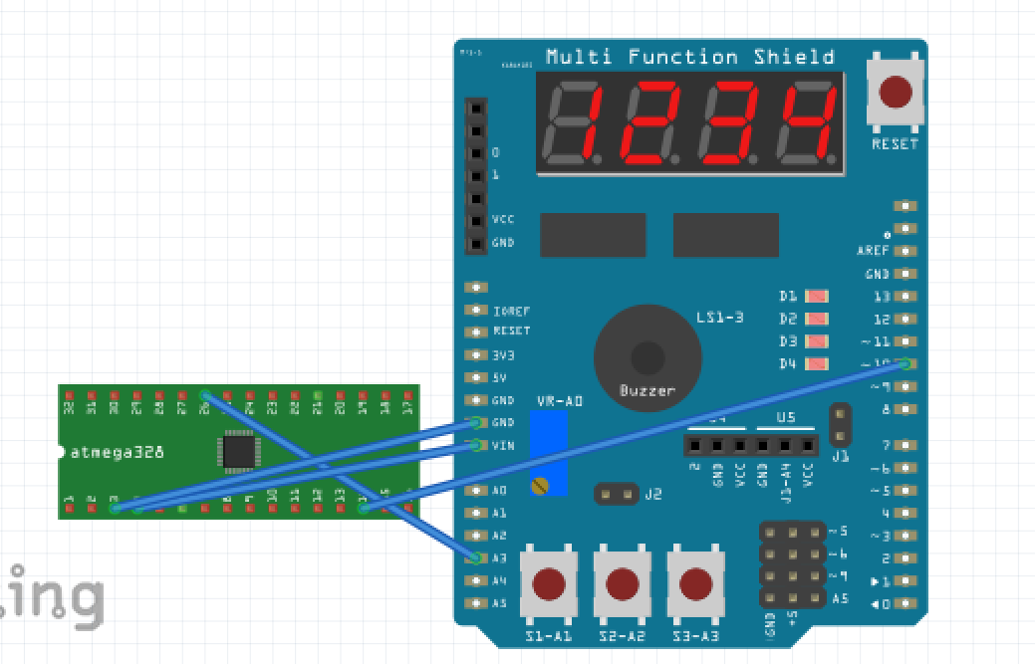

1. **SCREENSHOTS OF EACH TASK OUTPUT (ATMEL STUDIO OUTPUT)**

Task 1 :

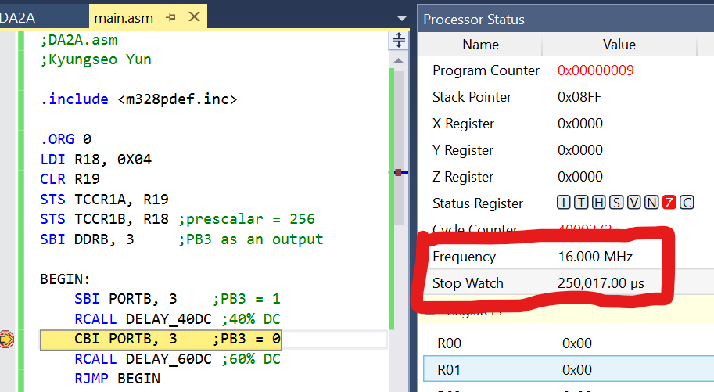40% DC (0.25 sec)

period 0.625 sec

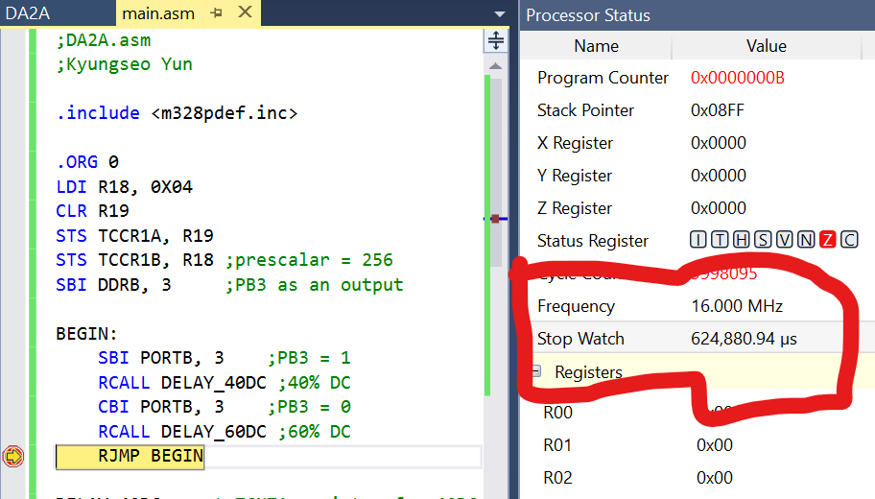

Task 2 :

LED on for 1.333 sec

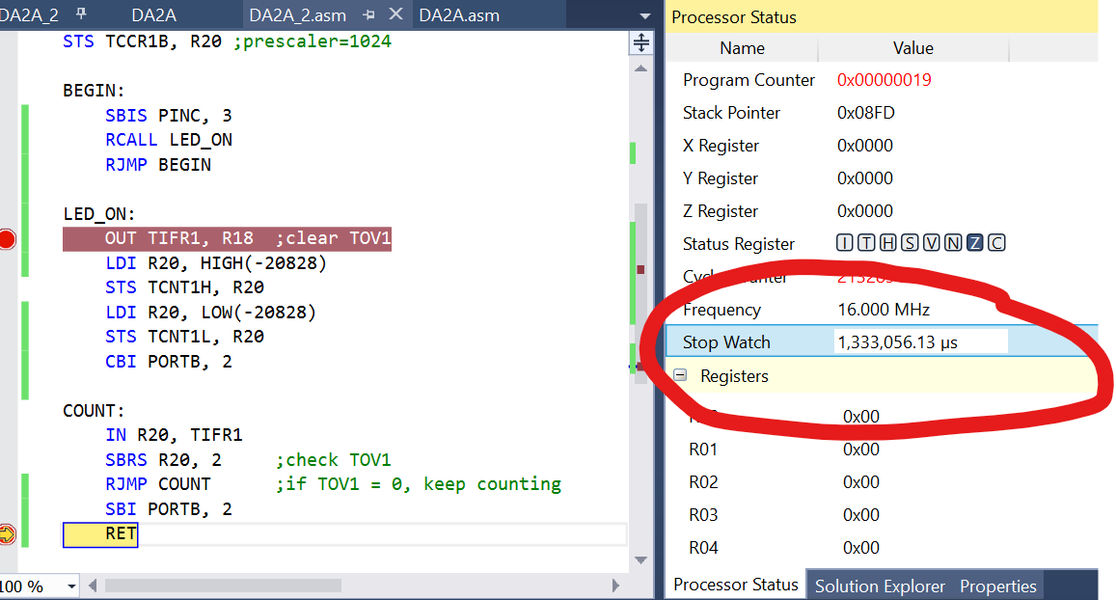

1. **C CODE VERIFICATION**

TASK 1:

/*

* DA2A_C.c

*

* Created: 11/3/2019 2:46:21 PM

* Author : jayne

*/

#include <avr/io.h>

int main(void)

{

DDRB = 1<<3;

TCCR1A = 0;

TCCR1B = 4;

while (1)

{

PORTB = 8;

TCNT1 = 49911; //40DC

while(TCNT1 != 0); //wait

PORTB = 0;

TCNT1 = 42108; //60DC

while(TCNT1 != 0); //wait

}

}

TASK 2:

#include <avr/io.h>

int main(void)

{

DDRB |= (1<<2);

PORTB |= (1<<2);

TCCR1A = 0;

TCCR1B = 5; //prescaler = 1024

while (1)

{

if(!(PINC & (1 << PINC3))){ //wait for PC3 input

PORTB = 0; //turn on LED

TCNT1 = -20928;

while(TCNT1 != 0); //count 1.333 sec

}

else//wait

PORTB = 0x04; //turn off LED

}

}

1. **SCREENSHOT OF EACH DEMO (BOARD SETUP)**

Task 1:

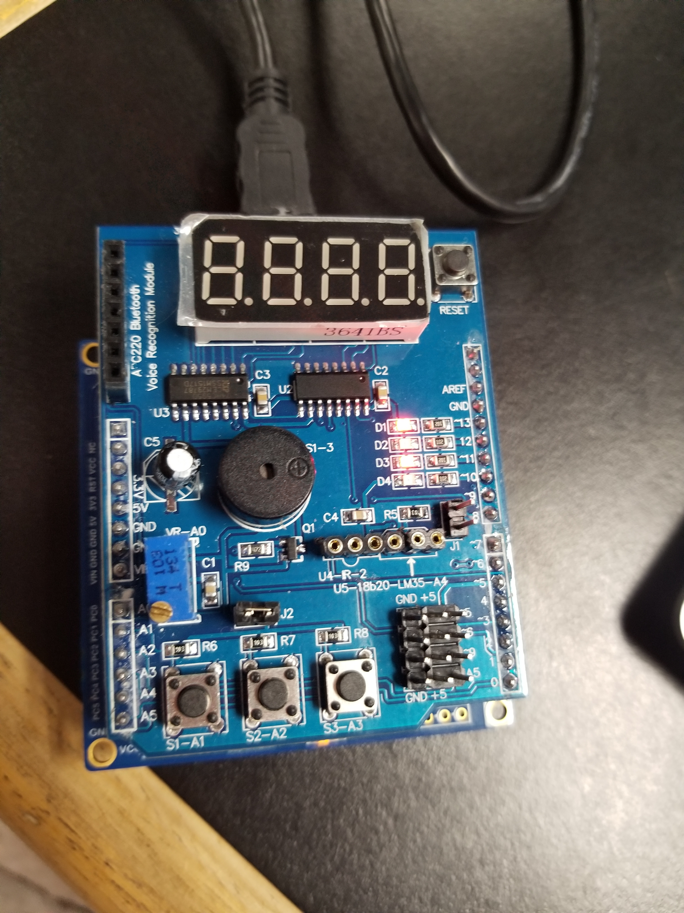

Task 2:

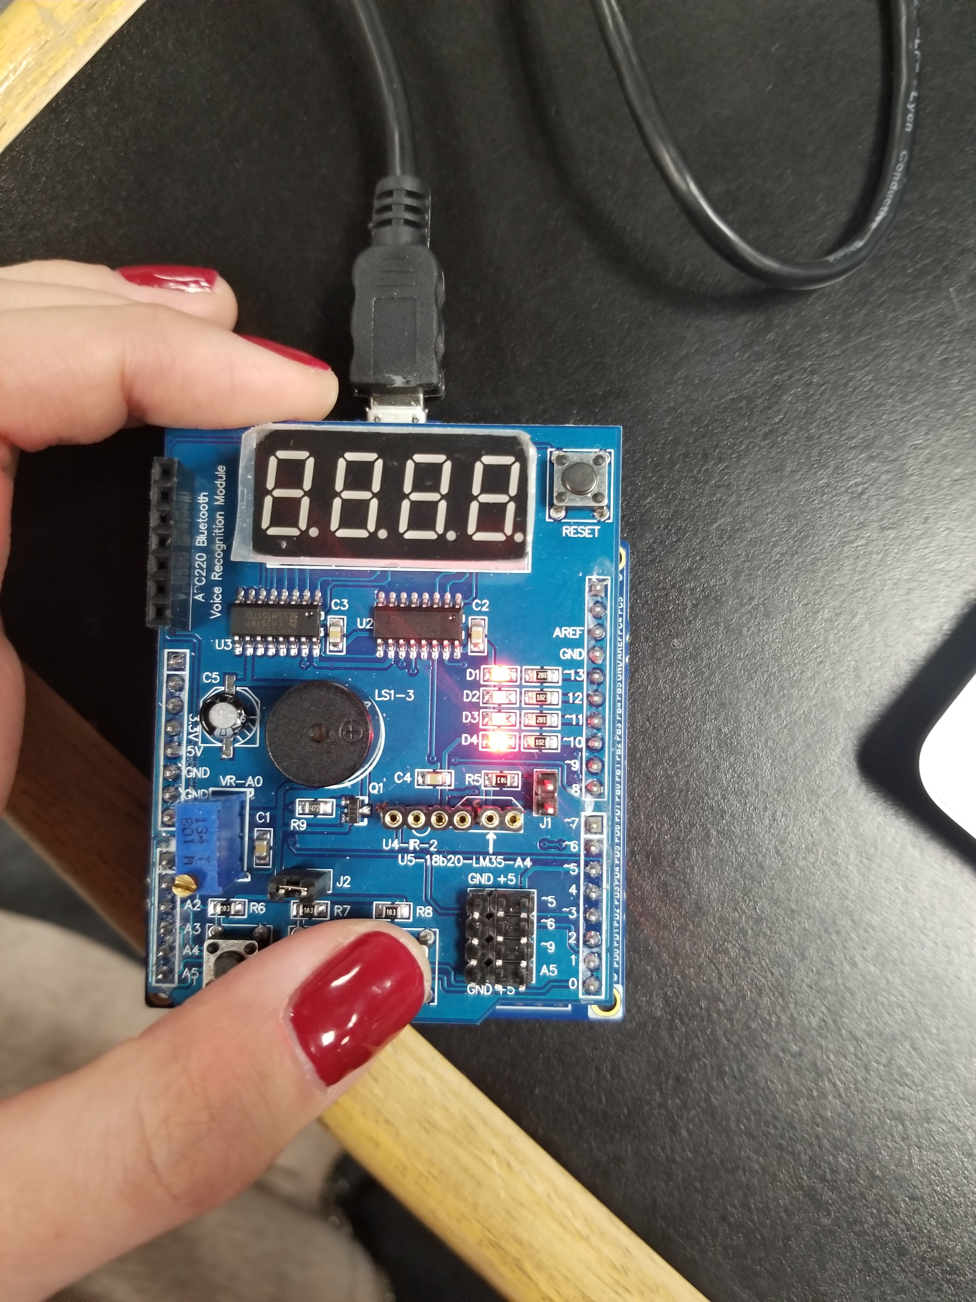

1. **VIDEO LINKS OF EACH DEMO**

TASK1 : https://youtu.be/eIideUOqEuw

TASK2 : https://youtu.be/qb030t3eC14

1. **GITHUB LINK OF THIS DA**

<https://github.com/biscuit0x/submission_yun/tree/master/DesignAssignments/DA2A>

**Student Academic Misconduct Policy**

<http://studentconduct.unlv.edu/misconduct/policy.html>

“This assignment submission is my own, original work”.

NAME OF THE STUDENT